September Newsletter

Miss Toaddy’s 5th Grade

Here’s what we will be up to this month!

**Reading** – We have just started our unit on metacognition and schema! We will be using these new topics to help us think about our reading and become better readers who use the text and their own knowledge while they read. We have just begun our guided reading groups. In these guided reading lessons, students will be able to work in small groups and with me to enhance their abilities to become strong readers who are reading for meaning! It is a very new but exciting process! We have also started a new technology based concept called google classroom! Ask your children to show you how it works!

MC900234083[1]**Writing** – We have recently started a new unit on personal narratives! Students will learn what it means to take a “watermelon” idea and turn it into a “seed”. At the end of this unit, students will have created a POWERFUL personal narrative. Students are working very hard to “dream the dream” and “live in the skin of the narrator”. Ask them about these terms and see what they can tell you! I am SO impressed by the level of writing your children possess! In this particular unit, students will be able to write about their own personal experiences using their schema!

MC900233968[1]**Math** – We are working towards finishing our first unit which stresses the understanding of area and volume. **Please remember to keep working on those multiplication facts at home so that it comes easily to students as they are working on new material that they learn**! The better students know their basic facts; the more confident they will be with the material we are working on in 5th grade!

**Social Studies** – We will be starting a unit studying the continents and oceans and our place on Earth! Our next unit of study will be locations and directions.

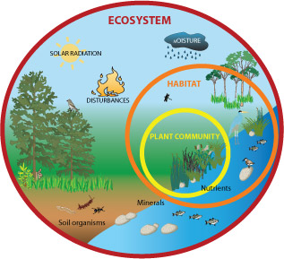

**Science** – We have just finished part of our unit on the ecosystem! The students did a wonderful job drawing ecosystems and labeling parts biotic or abiotic. Ask them what those words mean! They will be happy to share with you!

Important Notes!!!!

**9/2-** Early Release (Teacher’s Institute) - 11:00 AM

**9/2- Book Orders Due Today**

**9/5- No School-** Labor Day

**9/16-** Donuts and Juice Day- a reminder will be sent home if you signed up for this date

**9/23**- Early Release (Teacher’s Institute) - 11:00 AM

**9/30-** School Pictures

If you have not already signed up for remind 101, please do so. Directions can be found on the website!

*** Please make sure you are checking Skyward for updated grades****

**\*\* If you have any questions, please do not hesitate to ask.**

Miss Toaddy

[d2htoad@d52schools.com](mailto:d2htoad@d52schools.com)

<http://misstoaddysfrogs.weebly.com/>